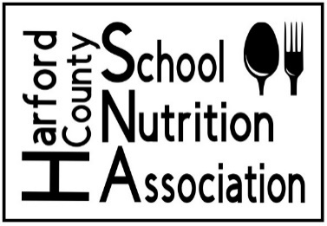
PLEASE NOTE: Scholarship Update JANUARY 8, 2024

Harford County School Nutrition Association
Scholarship Application Form
2 - $500 Scholarships will be granted.
Applicants must be pursuing a degree/certificate in the culinary/hospitality field.

Name: ____________________________________________________
Last First Middle Initial

Address: ___________________________________________________
Phone Number: _____________________________________________
Email: _____________________________________________________
High School: ________________________________________________
Requirements:
- Current GPA: _____________ (Please supply documentation to support)
- Compose a 250-word essay (no more than 500 words). Check your spelling!
Tell us about why you are choosing a path in the culinary/hospitality field.
- One letter of recommendation.
- Signed “agreement” by both student and parent/guardian.
Email completed application with requirements to the Harford County School Nutrition Association no later than 2pm on Friday May 3rd, 2024. Late applications WILL NOT be accepted. Applications received without requirements will not be accepted.
Email completed application packets to harfordcounty.sna@outlook.com
The following criteria will be used to select scholarship winners:
- A complete application packet is submitted; all required records and signed forms/letters are included with application and a minimum GPA of 2.0.
- Letter of recommendation.
- Quality of essay.
Judging and scoring is confidential.
SCHOOL ACTIVITIES
List years involved and level of involvement.
Organization:
________________________________________________________________________________________________________________________________________________________________________________________________________________________________________________________________________________________________________________________

Extracurricular activities:
________________________________________________________________________________________________________________________________________________________________________________________________________________________________________________________________________________________________________________________

Honors and Awards:
________________________________________________________________________________________________________________________________________________________________________________________________________________________________________________________________________________________________________________________

Favorite Food you’ve ever eaten in a school cafeteria and why:
________________________________________________________________________________________________________________________________________________________________________________________________________________________________________________________________________________________________________________________
Positions held in the hospitality field:
________________________________________________________________________________________________________________________________________________________________________________________________________________________________________________________________________________________________________________________

___________________________________________ _____________________
Applicant’s signature Date

Harford County School Nutrition Association
Application Agreement

- I confirm that the statements made in this application are true and correct to the best of my knowledge.
- I confirm that I am a graduating senior in Harford County Public Schools.
- I pledge that I will use my Harford County School Nutrition Association Scholarship funds to pay for my post-secondary education in hospitality/culinary field. My intent is to use these awarded funds to pay for my college tuition, certificate, fees, and or books.

_________________________________________________
Student’s Name (printed)
______________________________________________________________
Student’s Signature Date

___________________________________________________
Parent/Guardian name (Printed)
________________________________________________________________
Parent/Guardian Signature Date

